𝐀𝐫𝐭 𝐨𝐟 𝐃𝐞𝐬𝐢𝐠𝐧𝐢𝐧𝐠 𝐂𝐨𝐬𝐭-𝐄𝐟𝐟𝐢𝐜𝐢𝐞𝐧𝐭, 𝐇𝐢𝐠𝐡-𝐏𝐞𝐫𝐟𝐨𝐫𝐦𝐚𝐧𝐜𝐞 𝐃𝐚𝐭𝐚 𝐏𝐢𝐩𝐞𝐥𝐢𝐧𝐞𝐬

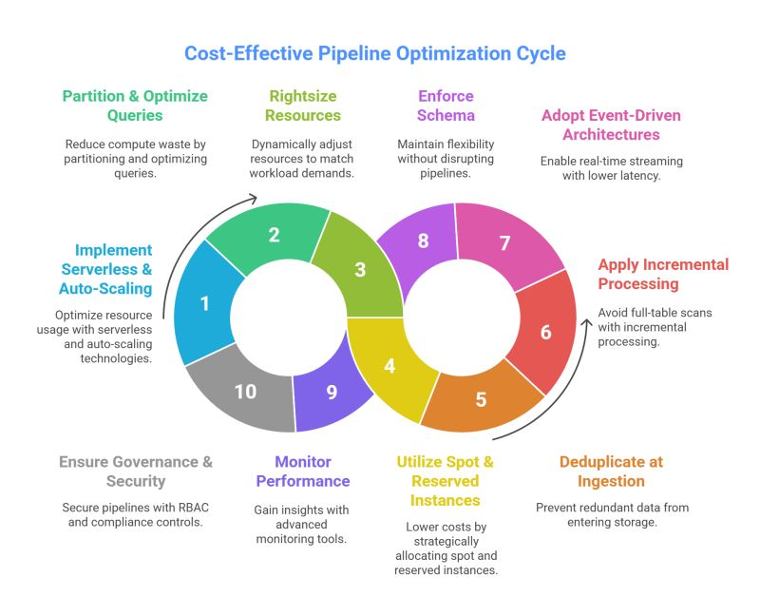  
  
🔍 Is your data pipeline working for you—or quietly working against you?  
  
 💸 Every year, enterprises burn millions on inefficient pipelines—🐢 slow queries, 💥 surprise cloud bills, and 🛑 scaling nightmares.  
  
🚀 A truly cost-efficient, high-performance pipeline means optimizing every single layer—from ingestion 📥 to analytics 📊—to deliver faster insights, lower costs, and smoother scaling without breaking the bank.  
  
⚠️ 𝟏𝟎 𝐑𝐞𝐚𝐥-𝐖𝐨𝐫𝐥𝐝 𝐃𝐚𝐭𝐚 𝐏𝐢𝐩𝐞𝐥𝐢𝐧𝐞 𝐂𝐡𝐚𝐥𝐥𝐞𝐧𝐠𝐞𝐬  
  
1️⃣ 💰 Skyrocketing Cloud Costs – Compute and storage bills spiraling uncontrollably.  
  
2️⃣ 🐢 Slow Query Performance – Minutes of waiting when milliseconds matter.  
  
3️⃣ 📦 Over-Provisioned Resources – Paying premium for idle capacity.  
  
4️⃣ ⚙️ Underutilized Compute – Wasted power and poor resource allocation.  
  
5️⃣ 📂 Data Duplication – Redundant storage bloating your budget.  
  
6️⃣ 🗂️ Unoptimized Data Formats – Inefficient storage dragging down processing speed.  
  
7️⃣ ⏱️ High ETL Latency – Missing out on near-real-time insights.  
  
8️⃣ 🔄 Schema Evolution Issues – Breaking changes halting your flow.  
  
9️⃣ 🔍 Limited Observability – Hidden leaks draining resources undetected.  
  
🔟 🔐 Security & Compliance Risks – Unmanaged data inviting costly breaches.  
  
✅ 𝟏𝟎 𝐏𝐫𝐨𝐯𝐞𝐧 𝐒𝐭𝐫𝐚𝐭𝐞𝐠𝐢𝐞𝐬 𝐟𝐨𝐫 𝐂𝐨𝐬𝐭-𝐄𝐟𝐟𝐞𝐜𝐭𝐢𝐯𝐞, 𝐇𝐢𝐠𝐡-𝐏𝐞𝐫𝐟𝐨𝐫𝐦𝐚𝐧𝐜𝐞 𝐏𝐢𝐩𝐞𝐥𝐢𝐧𝐞𝐬  
  
1️⃣ ☁️ Embrace Serverless & Auto-Scaling – Harness Azure Databricks, Synapse, and Functions for smart, on-demand power.  
  
2️⃣ 📊 Partition & Optimize Queries – Use Parquet/Delta Lake to eliminate compute waste and boost speed.  
  
3️⃣ 📏 Rightsize Resources Dynamically – Adjust VM sizes and clusters in real-time for peak efficiency.  
  
4️⃣ 💹 Leverage Spot & Reserved Instances – Cut costs dramatically with savvy allocation tactics.  
  
5️⃣ 🧹 Deduplicate at Ingestion – Block redundant data before it inflates your storage.  
  
6️⃣ ⚡ Adopt Incremental Processing for ETL – Skip full-table scans for faster, leaner operations.  
  
7️⃣ 📡 Build Event-Driven Architectures – Enable low-latency, real-time streaming that scales effortlessly.  
  
8️⃣ 📜 Enforce Schema Evolution – Keep pipelines flexible and unbreakable amid changes.  
  
9️⃣ 🔍 Implement Advanced Monitoring – Use Azure Monitor and Datadog to uncover and fix inefficiencies instantly.  
  
🔟 🛡️ Prioritize RBAC & Data Governance – Secure with Azure Purview for compliance without compromise.